MONITORING USE CASE
Problem statement-
Monitoring apache2 web application
AWS services used-
- Ec2
- Vpc
- Iam
- S3
- Cloudtrail
- Cloudwatch

Architecture diagram-
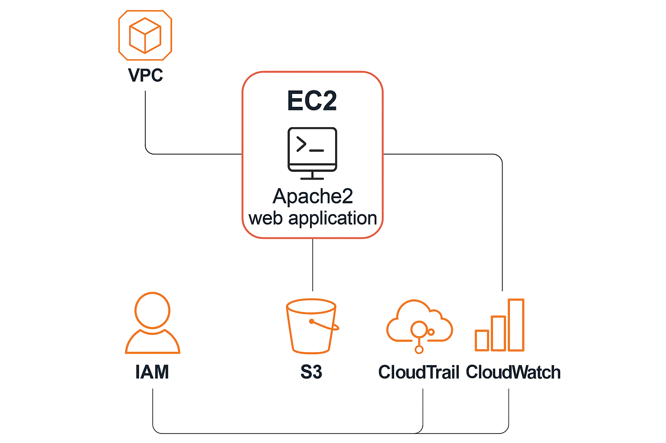

IMPLEMENTATION
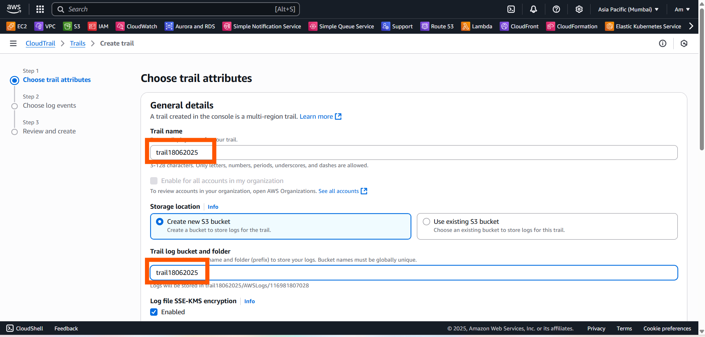
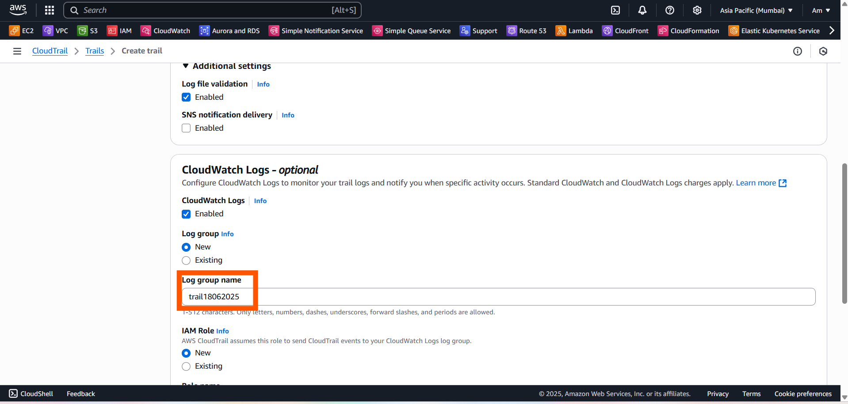

For IAM role/policy
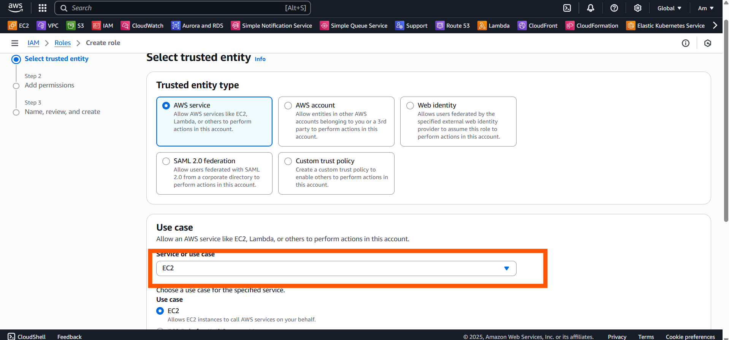
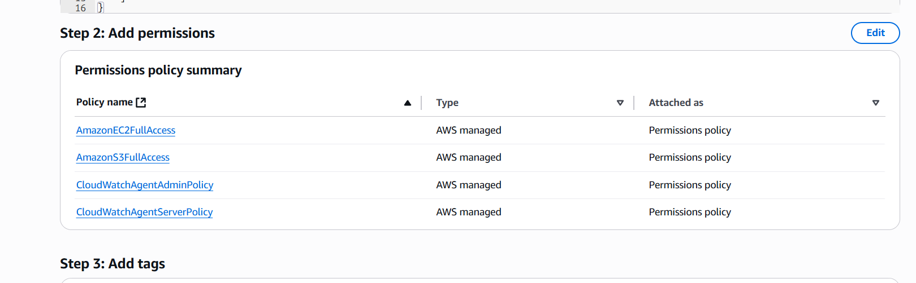
For iam user
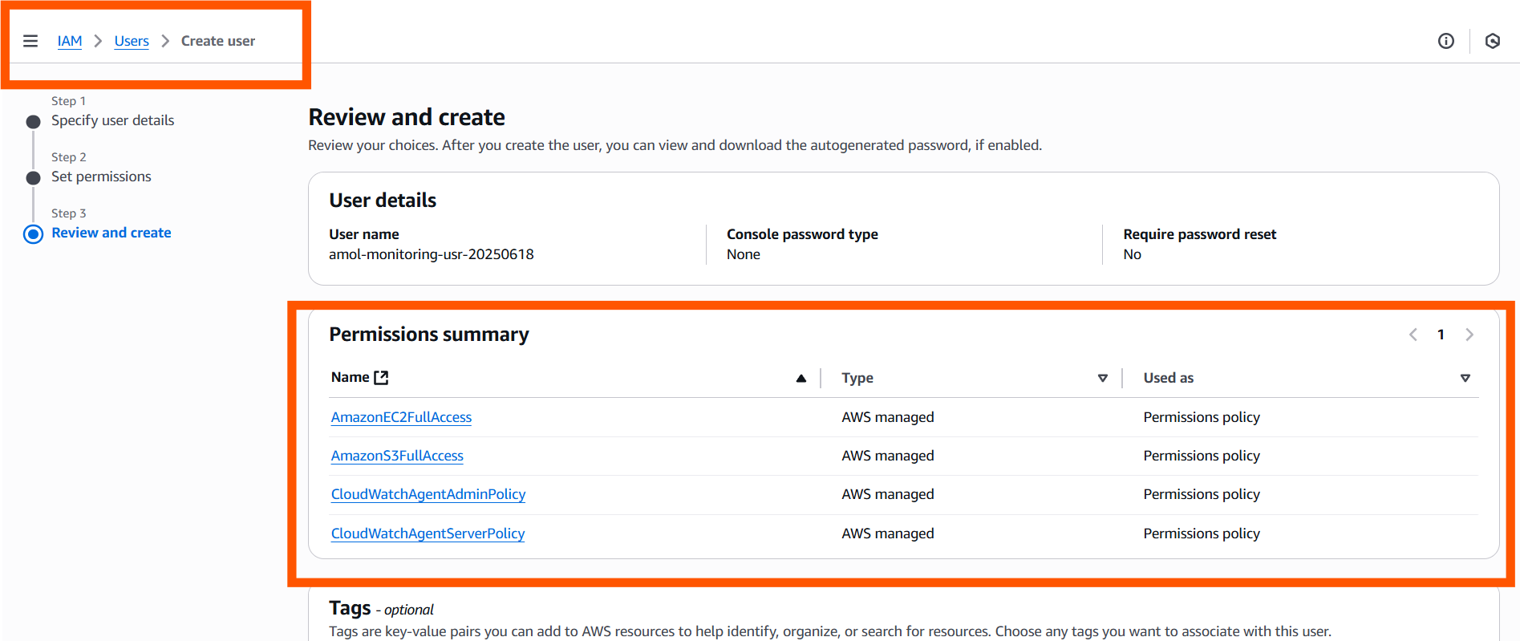

For Security-group
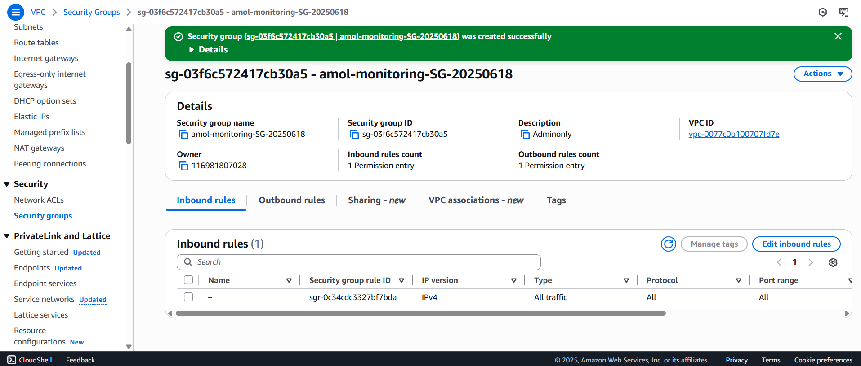
CLOUDWATCH AGENT CONFIGURATION
Before this run below command-
# Download the CloudWatch agent package
wget https://s3.amazonaws.com/amazoncloudwatch-agent/ubuntu/amd64/latest/amazon-cloudwatch-agent.deb

# Install the package
sudo dpkg -i -E ./amazon-cloudwatch-agent.deb
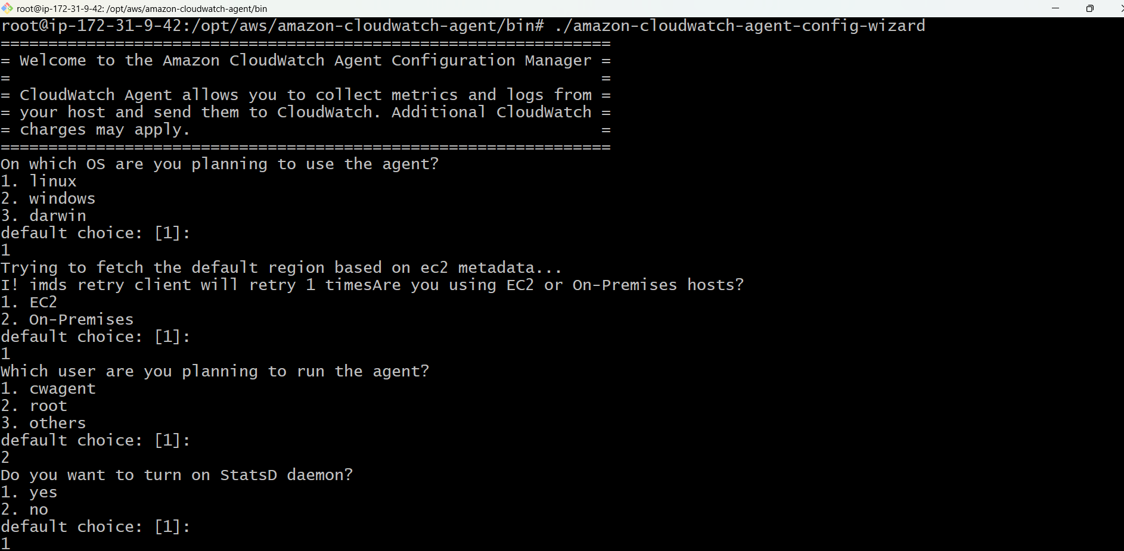
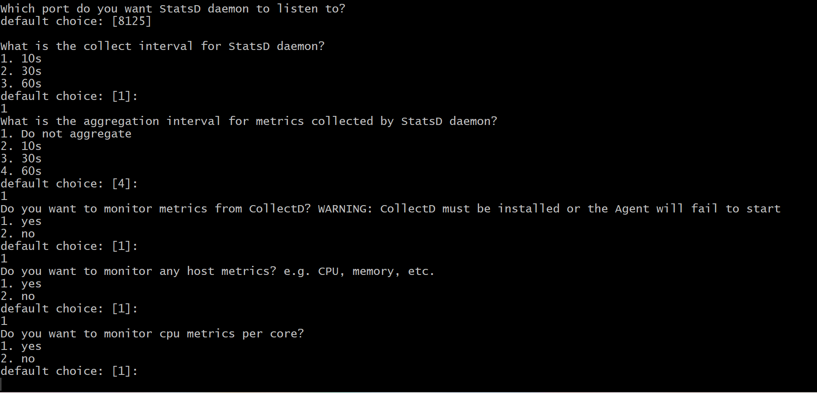
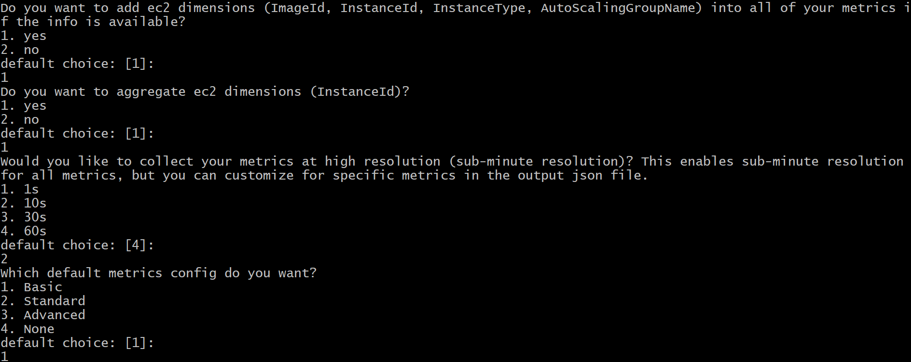
Json configuration
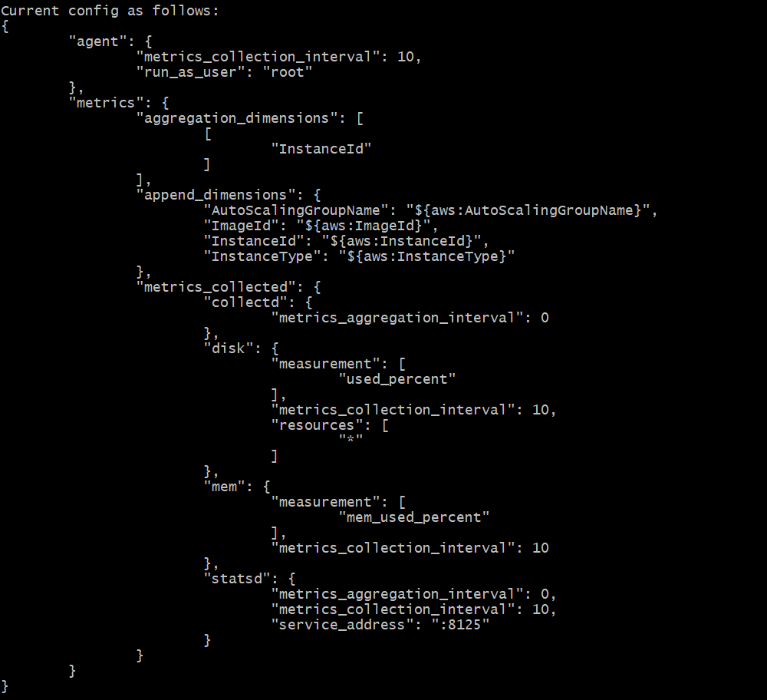
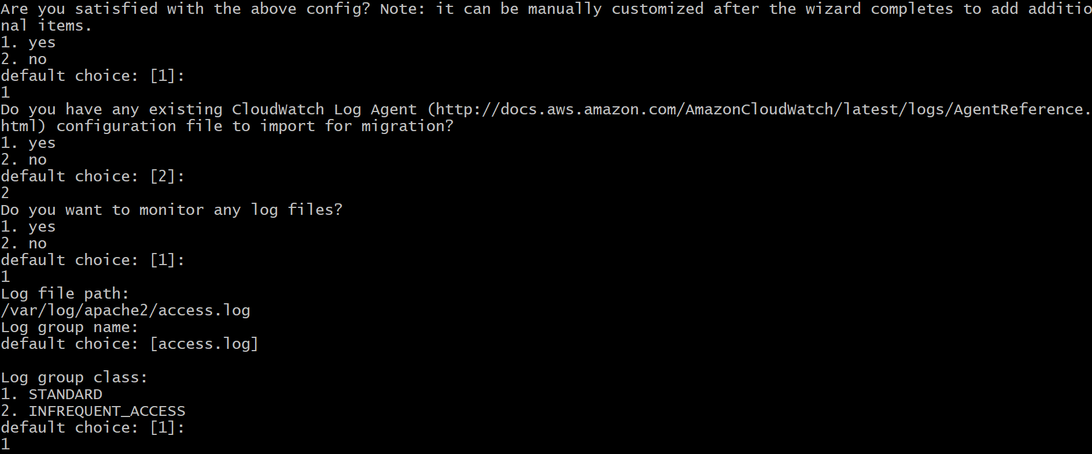
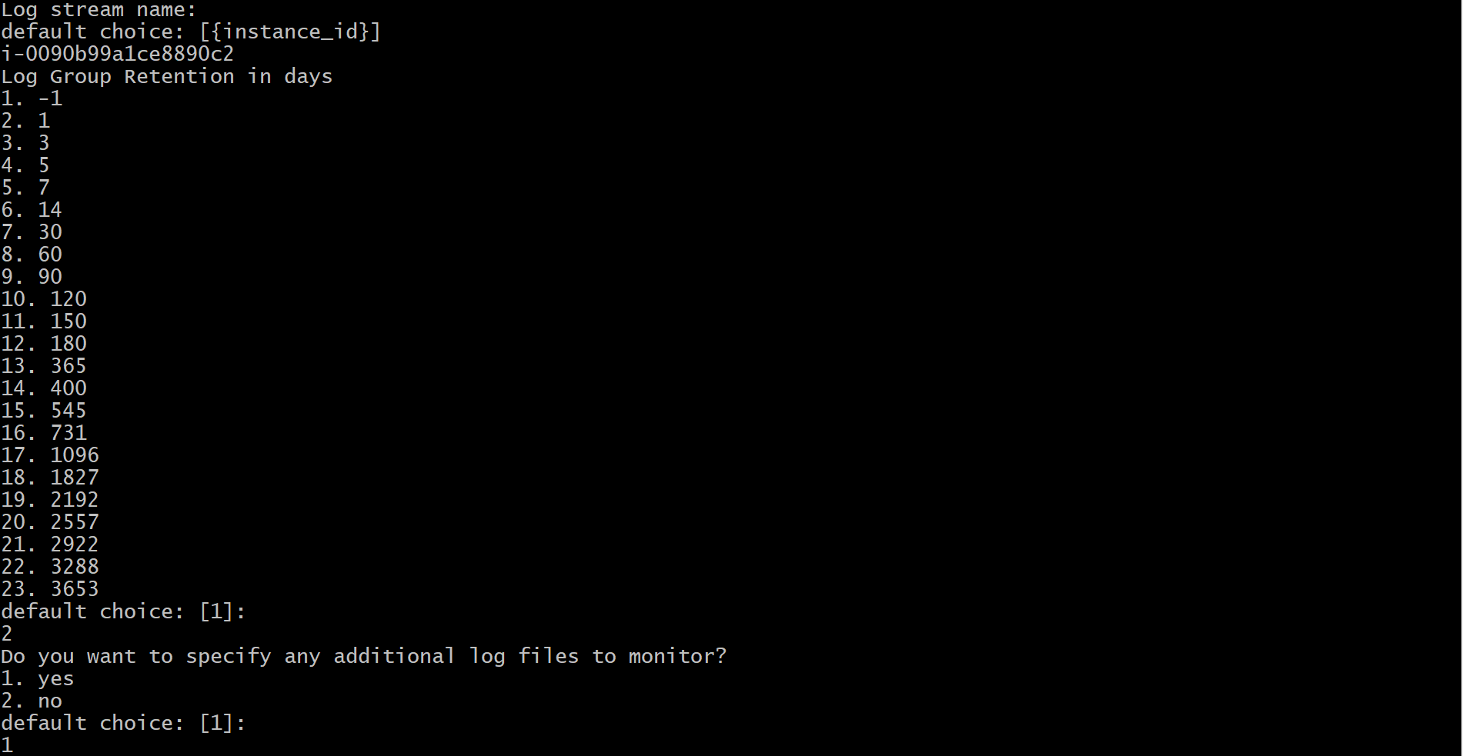
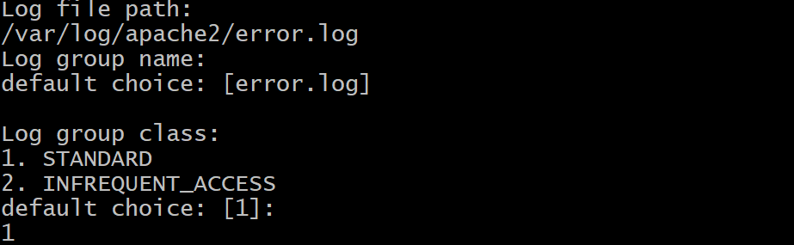
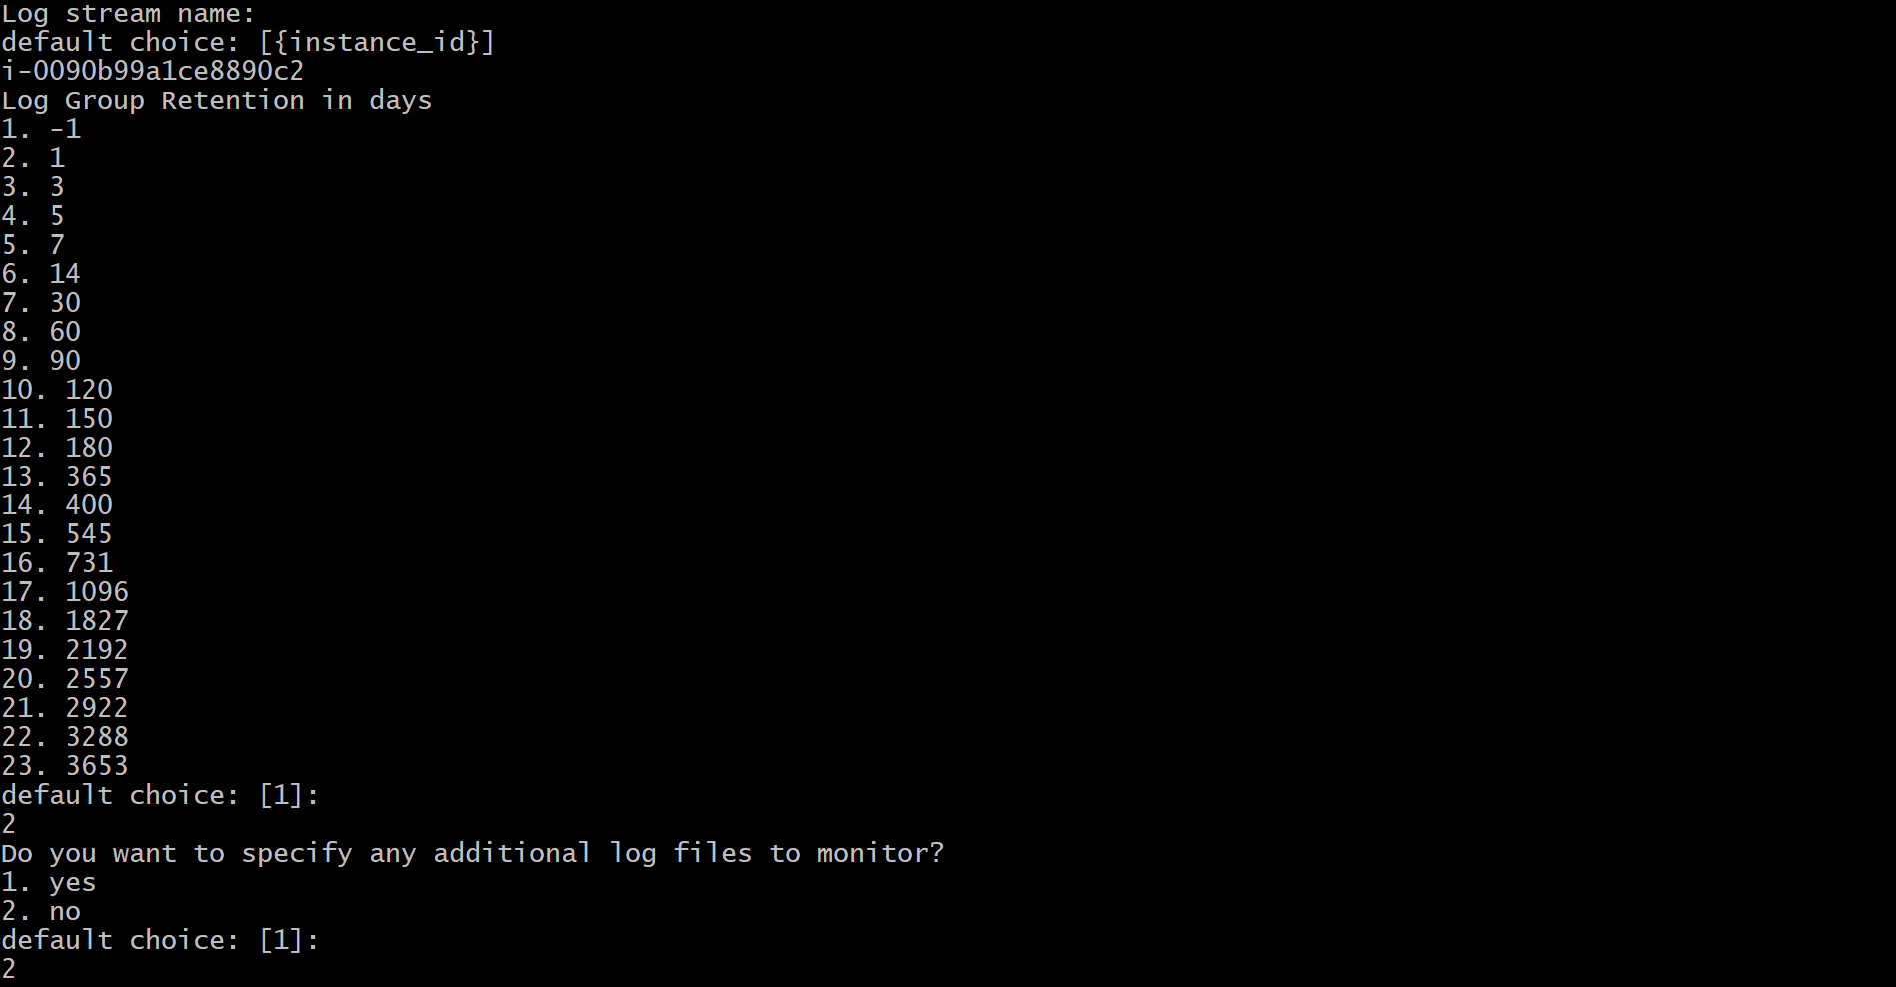
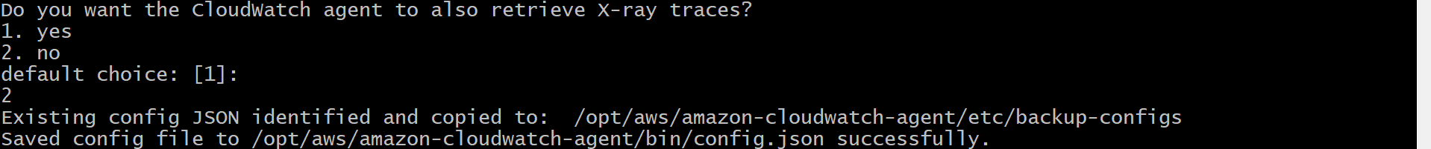
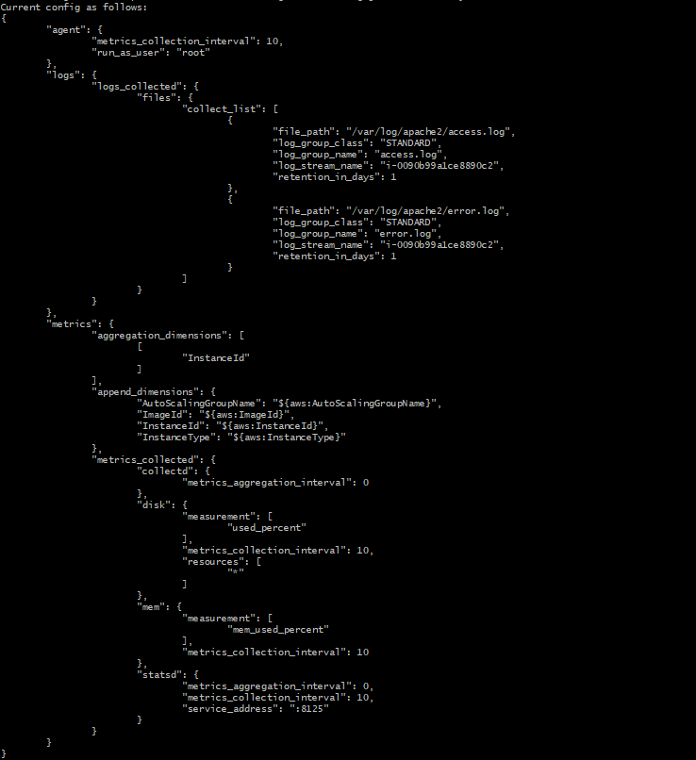
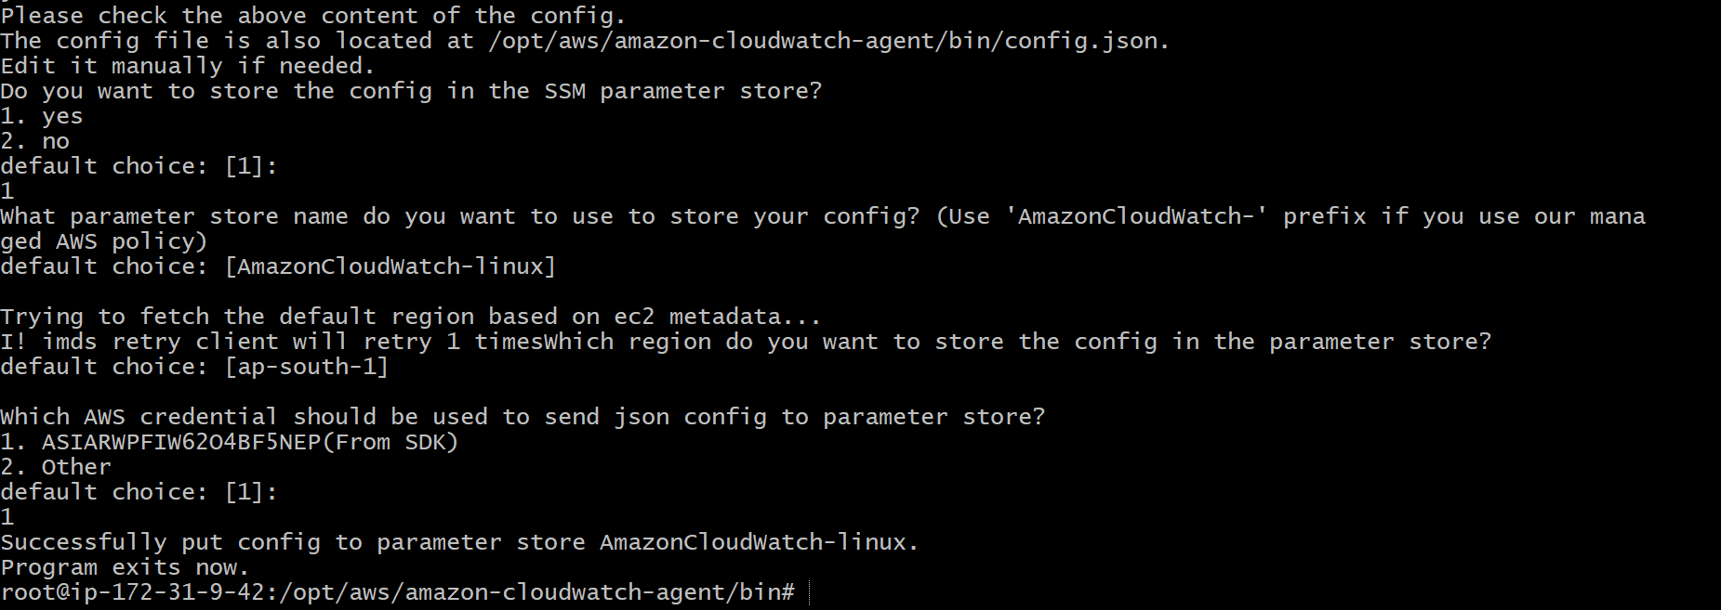

GIVING EXECUTION PERMISSION TO config.json FILE INORDER TO RUN CLOUDWATCH AGENT
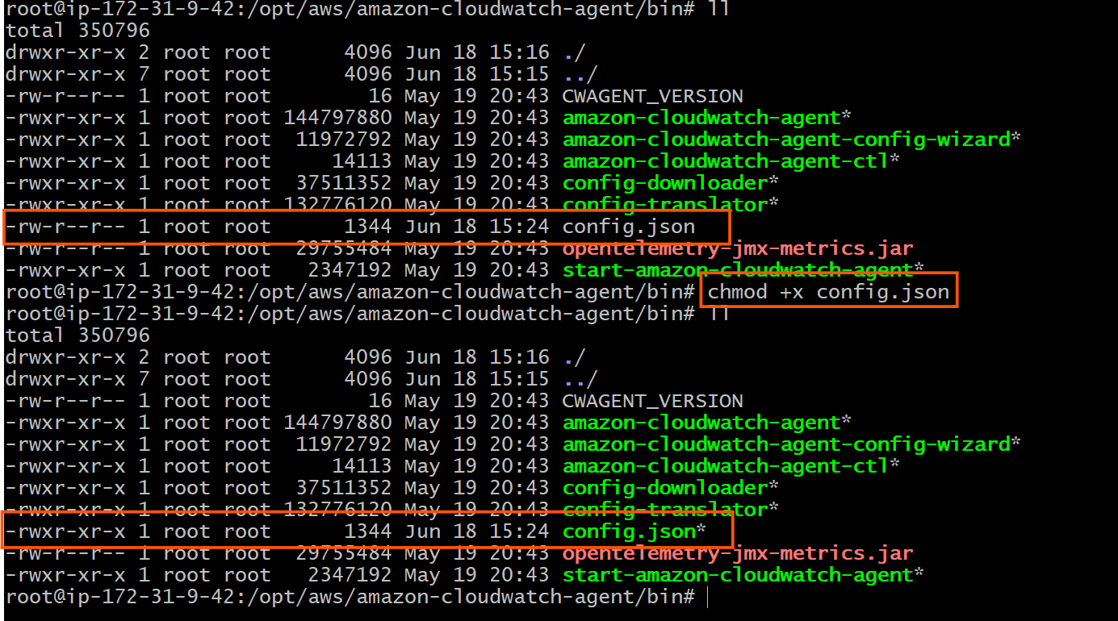

SUCCESSFUL CLOUDWATCH AGENT DEPLOYMENT
